Template for Full Paper (Replace with Paper Title)
PAPER CODE
Do not write anything

First Author¹, Second Author², Third Author³

¹PhD Student, Geotechnical Laboratory, Department of Civil and Environmental Engineering, Research State University, 1152 W Baker St., ST 999999; e-mail: imauthor1@csi.edu
²Assistnat Professor, Geotechnical Laboratory, Department of Civil and Environmental Engineering, Research State University, 1152 W Baker St., ST 999999; e-mail: imauthor2@csi.edu
³Professor, Geotechnical Laboratory, Department of Civil and Environmental Engineering, Research State University, 1152 W Baker St., ST 999999; e-mail: imauthor3@csi.edu

ABSTRACT

The authors must follow the instructions given in the document for its publication in the conference proceedings. The abstract should be concise and should include the objectives of the study, brief methodology, major results and principal conclusions. The length of the full paper should be restricted to Ten (10) pages. A single font type Times New Roman, is recommended throughout the paper. Single line spacing should be used throughout the paper and the text should be fully justified. Please email the full paper as both WORD and PDF files to egrwse2018@gmail.com (indicate your Abstract ID in your correspondence).

INTRODUCTION

In order to have a similar format for all manuscripts submitted to the EGRWSE-18, please use this document, which is provided as a template for full paper. The easiest way is to download the template, and copy-paste the content with your own material.
All the margins (left-right, top-bottom) must be 2.54 cm (1 in.). Title of the paper must be in 14 pt Times New Roman font type. Author’s names must be in 12 pt Regular font. Author affiliations must be in 12 pt.

METHODOLOGY

If you have images or figures in color it is always a good practice to print your paper out in black and white to ensure that the colors used are in good contrast so as to mark differences in colors when reproduced in black and white. However, the images will appear in full color in the electronic format of the proceedings. Image of your document should be at least 300 to 600 dpi for quality reproduction. All equations should be marked with equation numbers on the right as shown below.

$A=πr^{2}$ (1)

Sub-heading: Figures and tables must be centered. Figures must be numbered consecutively as they appear. Figures, such as Figure 1 must be introduced or mentioned in the text before it appears. Do not wrap text around the figure. The font size in figures must be atleast 8 pt for clarity. The font size of the contents of a table must be atleast 10 pt as shown in Table 1.

Table 1: Table Caption
Material | Property
 | Unit Weight (kN/m³) | Friction Angle (Deg) | Cohesion (kPa)
Sand | 17.5 | 35 | 0
Clay | 18 | 0 | 20

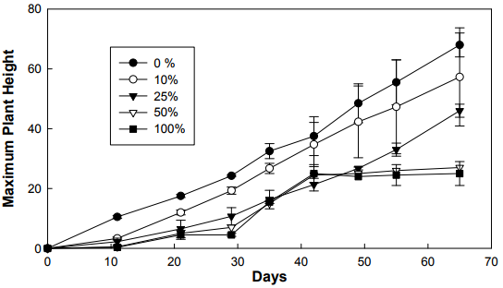
Figure 1: Figure Caption

Figure and table captions must be in 12 pt Regular Times New Roman font type and must be centered. Figure captions with appropriate figure numbers must be placed below their associated figures while table captions must be placed above the associated tables.

RESULTS & DISCUSSION

All hypertext links and section bookmarks will be removed from papers during the processing of papers for publication. If you need to refer to an Internet email address or URL in your paper, you must type out the address or URL fully in Regular font.

CONCLUSIONS

Reference should be listed at the end of the Paper. List references alphabetically. All reference items must be in 12 pt font. The format of the reference should as indicated in the references section below.

REFERENCES

Reddy, K. R., Kumar, G., & Giri, R. K. (2017). Influence of dynamic coupled hydro-bio-mechanical processes on response of municipal solid waste and liner system in bioreactor landfills. Waste Management, 63, 143-160.
Sharma, H. D., & Reddy, K. R. (2004). Geoenvironmental engineering: site remediation, waste containment, and emerging waste management technologies. John Wiley & Sons, Inc..

